Pandas - Challenge

Heroes of Pymoli

Vijitha Samarasinghe

Observable Trends in Heroes of Pymoli Data Analysis:

Heroes of Pymoli, like many others in its genre, the game is free-to-play, but players are encouraged to purchase optional items that enhance their playing experience. Optional item purchase of Heroes of Pymoli data set analyzed using panda library build in Python via virtual Jupyter Notebook.

Gender Demographics

The total of 576 unique players, performed 780 transactions. The Gender analysis of players has clearly showed that 84.03% percent are male players which is approximately six times (5.97) compared to 14.06% female players (Figure 01).

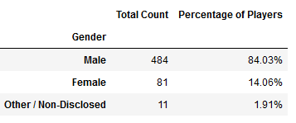

Figure 01: Heroes of Pymoli – Gender Demographics

Total purchase value made by male players were $1,967.64 which is almost six times of female players spent. It is concluded that purchase of optional items to play Heroes of Pymoli affected by the Gender. There is a trend among males players to purchase the optional items than the female players. (Figure 02)

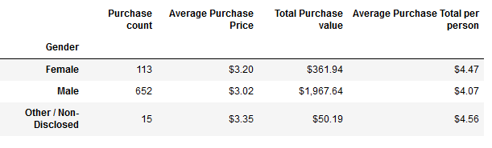

Figure 02: Heroes of Pymoli – Gender and Transaction

Age Demographics

Age demographics analysis showed, the highest percent, 44.79% optional item purchase was made by age group between 20 to 24 years. The second highest purchase age group was between 15 to 19 years. Surprisingly, age below 10 years also shown 2.95% from the total players. There is a trend to purchase optional items to play Heroes of Pymoli is increased with the age and reached the maximum around age 20 to 24, then it drastically drop at age between 30 to 34. The lowest percent of players, who bought optional items were players age 40 and above, which is 2.08%. (Figure 03).

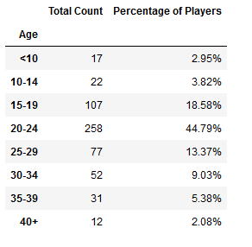

Figure 03 - Heroes of Pymoli – Age Demographics

The total purchase count of 365 was made by age group 20 -24, while age 40 or above has made 13 purchases. The Heroes of Pymoli made, total of $1,114.06 revenues from players belongs to Age between 20 -24, which 28 times of revenues made from age 40 and above group. (Figure 04). It concluded that purchase of optional items to play Heroes of Pymoli affected by the Age of the players and highest tendency to buy optional items is popular among age between 20 -24. (Figure 02)

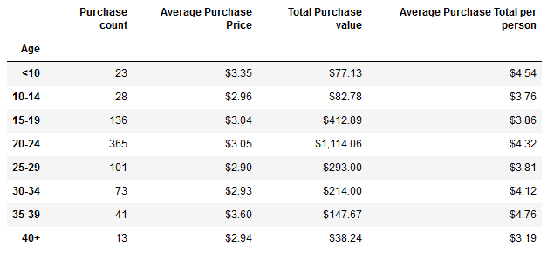

Most Profitable and Most Popular Optional Items

According to the analyzed data the most popular as well as most profitable item was Final Critic, which was purchased by 13 payers and total revenue is $59.99. The second most popular as well as most profitable item was Oathbreaker, Last Hope of the Breaking Storm, which was purchased by 12 players and total revenue made was $50.76. (Figure 05)

Consideration of features in Final Critic and Oathbreaker, Last Hope of the Breaking Storm can reveal more information to increase the optional purchases.

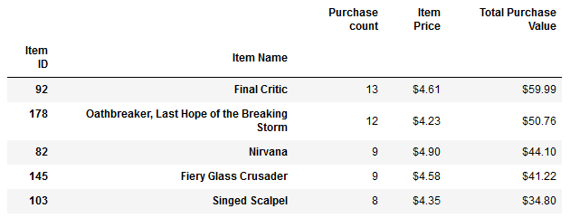

Figure 05: Heroes of Pymoli – Most Profitable and Most Popular Optional Items